

**GROUP ASSIGNMENT**

**Intake Code: APD1F2209CS(CYB)**

**Module Code: CT109-3-1-DGTIN**

**DIGITAL THINKING AND INNOVATION**

**Lecturer: Ms. Khalida Harun**

**Hand-In Date: Week 2**

**Hand-Out Date: Week 11**

-**-------------------------------------------------------------------------------------------------**

|  |  |
| --- | --- |
| **Name:** | **TP Number:** |
| Abdulrahman Gamil Mohammed Ahmed | TP071012 |
| Hans William kihigwa | TP071413 |
| Ibraheem Mohammed Imadeldin Awad (Leader) | TP070765 |
| Fouad Mohamed | TP069613 |
| Saif Waleed Abdelrahman Sayed Abdelsalam | TP068702 |
| Adham Sobhy Abdalla Elshazly | TP068700 |
| Khan Abdul Shafey | TP071166 |
| Abdul Rahman Awadh Masoud | TP069361 |

**Table Of Contents**

1.0Introduction:…………………………………………………………………………………………...3

2.0 Existing systems Review (Online Education System): 4

**2.1 Progress tracking: 4**

**2.1.1 Issues: 4**

**2.1.2 Proposed Solutions: 5**

**2.2 Anti-Cheating: 6**

**2.2.1 Issues: 7**

**2.2.2 Proposed Solutions: 7**

**2.3 Network Tracking: 8**

**2.3.1 Issues: 8**

**2.3.2 Proposed Solutions: 8**

**2.4 Learning Management: 10**

**2.4.1 Issues: 10**

**2.4.2 Proposed Solutions: 11**

3.0 Existing systems Review (Attendance System): 12

**3.1 Taking attendance: 12**

**3.1.1 Issues: 12**

**3.1.2 Proposed Solutions: 13**

**3.2 Attendance tracking: 14**

**3.2.1 Issues: 15**

**3.2.2 Proposed Solutions: 15**

4.0 Existing systems Review (Identification System): 17

**4.1 Identity Management: 17**

**4.1.1 Issues: 17**

**4.1.2 Proposed Solutions: 17**

**4.2 Identification cards: 18**

**4.2.1 Issues: 18**

**4.2.2 Proposed Solutions: 18**

5.0 Conclusion: 20

6.0 References: 21

7.0 Appendices: 25

**7.1 Work breakdown Structure: 25**

**1.0 Introduction:**

In brief, the secondary school sector is the educational domain that our group would want to explore. That segment's demographic ranges in age from 13 to 18. Without a high school education, children will only have a few job alternatives in the future. Although completing high school will create a proper long-term basis, it is not an easy step. Students in high school receive the fundamental education they need, as well as additional information, modern skills, technology preparedness, and interpersonal abilities to meet the challenges that lie ahead in addition to receiving the fundamental knowledge required for success in their future endeavors, students also learn the art of socializing and how to control their behavior and responses in difficult situations and they become more accountable. Grades from high school are an essential requirement for entrance to a reputable college. It also affects the degree you choose and the career the student will follow. Students must use their high school years wisely so that they may enjoy the rest of their lives and have an excellent job. Failure to perform well might be detrimental to the future by restricting their options for top schools and higher education and forcing them to accept low-paying employment. One of life’s steppingstones is high school. High school might be challenging, but to stay motivated, kids should think about their future accomplishments. More options to select the appropriate stream after 10th grade will arise in the future for children who perform well in high school. They will never again experience a setting like a high school. The high school offers a distinctive experience, so parents should make sure that they select good schools in their home country to give their children a solid foundation for a successful future. (Ashok Deepan, 2022).

And there are many common subjects in most of the high schools:

Math which includes geometry, algebra, and trigonometry. English: covers the basic grammar rules, words, and develops four skills (speaking, listening, writing, reading). Science involves physics, biology, chemistry, etc. History: common civics and history of the countries. Computer: the popular protocols and basic computer skills that are required by most employers, etc. Health: the cells of the body and the diseases. (Thomas, 2018).

(369 Words)

# **2.0 Existing systems Review (Online Education System):**

## **2.1 Progress tracking:**

Progress tracking is a method by which an educational institute manages and tracks students’ progress to monitor and assess their academic performance, quantify their rates of improvement or progress toward goals, and determine how they are responding to different instructions (Renaissance,2022). Due to the Covid 19 pandemic online education has become more widespread than ever. There used to be a small number of schools that offered online education but after the pandemic the whole world went into lockdown and schools had to teach students in a remote manner (Pokhrel, S., & Chhetri, R. 2021).

Progress tracking can be done in many ways. One way in which teachers can track students' progress can be through tests and quizzes after classes and then that information is stored in the system. Students are encouraged to take charge of their education by keeping track of their academic progress as there are scientifically proven benefits to doing so. It promotes the growth of the abilities needed to become a better learner. Students must be able to keep track of their own academic progress. Doing so promotes metacognition, or awareness of one's own thought processes, which has been linked to higher levels of achievement. It enhances the learner's capacity to specify, design, or make requests for the circumstances necessary to satisfy their learning needs (Green, C. 2021). Teachers are also encouraged to use the progress tracking systems to understand students’ nonacademic needs which could also be a factor leading to an improvement in the grades and overall understanding of the students (Rosier, S., PhD. 2021).

### **2.1.1 Issues:**

Progress tracking systems have many flaws as a lot of people mostly use tools like Microsoft Excel to store data related to grades and student academics manually, then they use that stored information to track students’ progress hence, they do not really pay attention to progress tracking features and applications designed for such tasks. This process is very inefficient and prone to many errors as all the data is entered by humans and humans tend to make mistakes which is a common thing. Many schools do not have proper implementations of progress tracking software. This often leads to students’ progress not being recorded as intended which causes a lot of problems for both the students whose progress was not accounted for in their final grade causing them to get a lower grade than what they should have gotten and teachers who must keep track of every progress for every student to make the final grading as fair as possible.

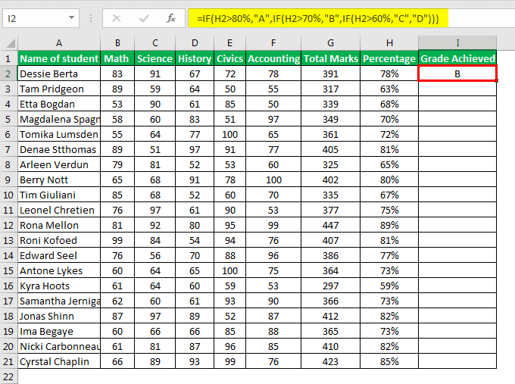

**Figure 1:** Teachers recording grades manually into an Excel sheet.

### **2.1.2 Proposed Solutions:**

The system created for this issue allows both students and teachers to monitor the students' progress making sure that they get regularly updated whenever they have either an assignment due at a near date or the results of an exam that they did recently have been published. This allows them to stay on track when it comes to studies and schoolwork without having the need to cram work and spend multiple nights awake working on an assignment that they had a long time to complete. The system automatically recognizes and records the exam data of the students after every exam is conducted and completed. After all the data is collected based on either a curve or a set record in the system of the school the information system automatically gives a grade based on the average of all the results collected for each student making the grading process as error free as possible. The application also sends progressive reports in the form of emails to the students’ parents to keep them informed about the progress of their children.

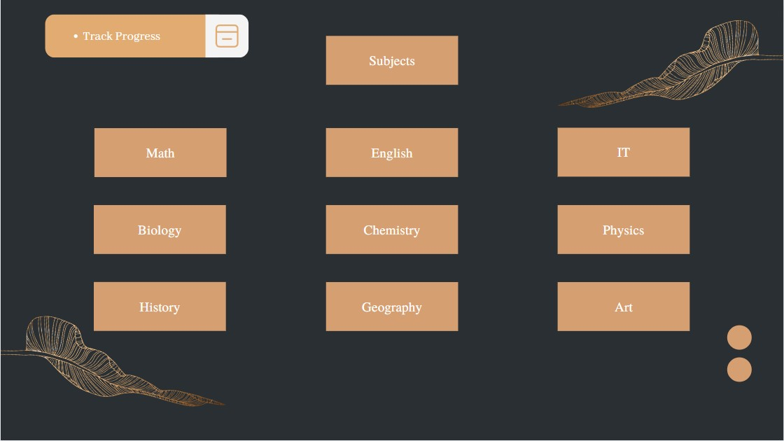

**Figure 2:** All the subjects that students are taking in school.

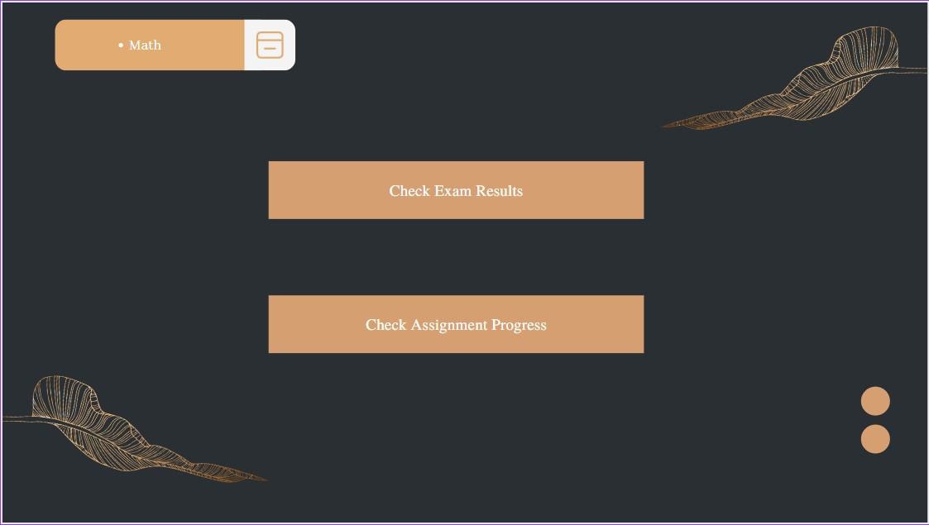

**Figure 3:** Checking assignment progress, and Exam results.

## **2.2 Anti-Cheating:**

Cheating is engaging in dishonest action or breaking the rules. Students these days produced new ideas for cheating. They use technology to their advantage and devise new cheating methods. High schools should consider this big problem and consider new protocols to prevent students from taking what they do not deserve. So, an anti-cheating system will control students' behaviors (Borup, Walters and Call-Cummings, 2020). The anti-cheating system for exams is designed to prevent cheating by students during online exams. It is a system that uses technology to detect and prevent cheating by students. This system is also a great way to keep exams fair for all students (Nicholls and Lewis, 2017).

### **2.2.1 Issues:**

In the past few years, cheating has started to spread among students and become a major problem. It is estimated that over 50% of students have cheated on a test or assignment at least once (Nicholls and Lewis, 2017). This is a major concern for educators, as it can lead to lower grades and a loss of knowledge. Cheating can also lead to disciplinary action from schools. The past 3 years of the pandemic have been particularly difficult for students, as they have had to adapt to new learning environments and deal with the stress of the pandemic. This has led to an increase in cheating as students try to keep up with their studies (Noorbehbahani, Mohammadi and Aminazadeh, 2022).

The first issue is impersonation, which is used by students to obtain illegal entry into exams by posing as another person to solve their friend's exam to get him higher grades. The second issue is that students are taking their exams and solving them together in the same place, and it is forbidden for students to share answers during their exam time (Nicholls and Lewis, 2017). The third issue is that students search the internet for exam answers while they are taking the test. This is especially common in online exams, where students can easily open a new browser window and search for the answers without their teachers noticing. The fourth problem is students sharing answers online. Although students were separated during corona, each student took the exam online from home, and students managed to share answers using online platforms. When students share answers on online platforms, they are deceiving their instructors and classmates and misrepresenting their own knowledge and abilities (Borup, Walters and Call-Cummings, 2020).

### **2.2.2 Proposed Solutions:**

The system takes control of students’ cameras throughout their test period; it also verifies their face IDs before the start of each exam so that no impersonation happens. The system also takes control of the student’s location, which will be known by the school. The use of location services is to compare students’ locations and detect if they are taking the exam together. It helps to ensure that students are not cheating by looking at each other’s answers and that students are where they are supposed to be during the exam. In addition, a quiz timer is a great way to keep students from cheating on quizzes. By setting a timer, students will have a limited amount of time to search for answers to their questions. This will keep them from being able to look up answers on their phones or in other materials. Finally, there is plagiarism detection software that compares students’ answers to online websites and then generates a similarity report.



**Figure 4:** Students place their face into the frame for it to be scanned.

## **2.3 Network Tracking:**

If we went 100 years into the past, we would find schools, especially high schools, with teaching based on books (the 1993 National Center for Education Statistics (NCES) report), but now everything is computerized and based on the internet. Students are now using tablets or iPads instead of huge library books of 500+ pages. In high schools, students use their tablets as resources or books for their studies, but the internet is limited for students in high school. Because schools provide students with tablets to study on, they might as well provide them with internet to use while studying rather than having them pay for it themselves. School provides each student with an internet quota for their studies and online classes like Zoom that should last until the end of the month. Some students complain that the amount of data given is not enough for their studies. But how will the high schools know that the students are not lying, and that the internet is not enough? Some students use the internet for gaming, social media, or whatever they want because no one can tell whether they are using it for educational purposes or not.

### **2.3.1 Issues:**

When it comes to the problems, we will discover that this system has 2 key issues: the Internet limit allotted to every student is insufficient for students to keep up with their studies, Students cannot track their internet usage as there are no tracking apps given to students.

### **2.3.2 Proposed Solutions:**

The following app has been made and based on research it is found that tracking is the best solution for many online system problems. Internet tracking would help students track their usage and know where the internet goes. The high school administration will receive internet tracking reports monthly for review and research into whether they are providing students with adequate internet access. If not, they will increase the quota for students using the internet for educational purposes only. Since high schools provide tablets to students, they will provide them with a software update to fix internet issues. The internet tracking app will be installed immediately after the update. Students will use this app to track their usage and see where their internet goes. The school administration has access to this internet data to determine whether the problem is caused by them or by students. The app is simple so the students can find what they want from it without facing any problems. As shown in the user interface, the app includes everything a student requires for an internet tracking system. When students receive their tablets, they will set them up and open the internet tracking app. Once they open it, they will find guides on how to use it.

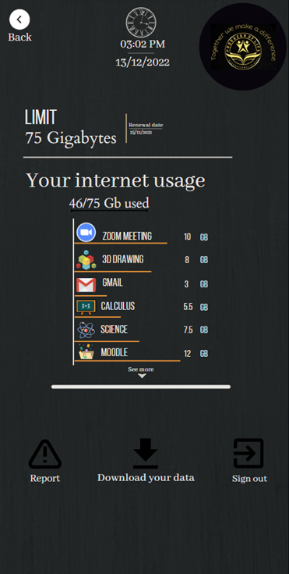

**Figure 5:** Network tracking app.

## **2.4 Learning Management:**

In the educational space, software technology and learning management (LM) systems have seen a dramatic increase in usage worldwide (specifically in secondary and post-secondary education) (Turnbull et al., 2020). Moodle, Blackboard, and Sakai are the most popular LMS systems prevalent in high schools. These are user-friendly GUI-LMSs that are simple to operate and possess unique characteristics that make them ideal for the application of Human-Computer Interaction (HCI) (Machado & Tao, 2007). The LM systems include all conventional LMS components and are designed in such a way as to organize and display the classes or courses of a user. Furthermore, their interfaces include various tabs that are displayed to and are accessible by the user, such as timetables, assignment submissions, user profiles, messages, grades, wikis, glossaries, preferences, etc. (Machado & Tao, 2007).

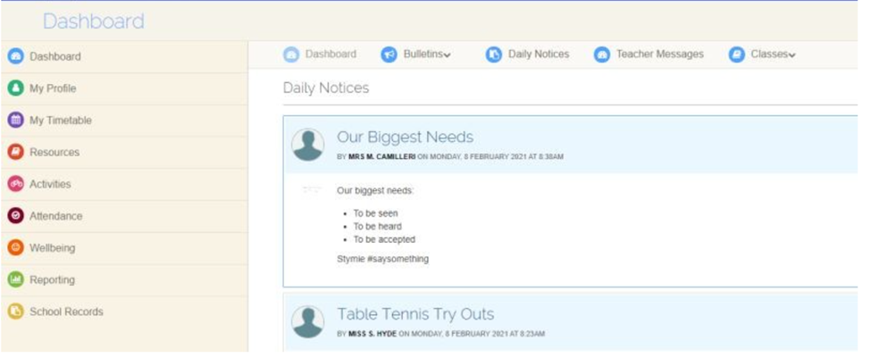**Figure 6:** System Design & UI of a High school LMS (Cecil Hills High School, 2021)

### **2.4.1 Issues:**

Actively engaging and interacting with peers is paramount for any learning process, but its role is even more paramount in e-learning. Research has discovered that a student's continuous engagement in learning improves learning, a process known as active learning. Moreover, according to (Panyajamorn et al., 2018), learner-learner interaction includes communication between peers to perform a course-related exercise and an informal conversation about the class topic. Research has shown that High school students have a concise attention span and are prone to be distracted by social media or external activities during e-learning sessions or group sessions (Balan et al., 2021). Therefore, successful learning requires involvement, reaction, emotional feedback, and brief, targeted messages among learners in an online LMS like MOODLE (Panyajamorn et al., 2018). While the LMSs as mentioned earlier have been utilized by various institutions worldwide to assist and enhance their students' learning, they are intended primarily for course management. Therefore, they have little influence on active learning (Chang & Kuo, 2021). These systems are unable to engage a student during their learning period due to a lack of interaction channels, cooperation methods between learners and instructors, and limited scope for collaboration between courses. Due to these constraints, LMSs are ineligible to facilitate e-learning in the contemporary age, which considers learning a self-governed, problem-based, and interactive social activity particularly for highschoolers (Du et al., 2012).

### **2.4.2 Proposed Solutions:**

Interaction between learners is necessary for practical and profound learning (Almoslamani, 2018). Interaction is activity between individuals resulting from mutual impact by which they may communicate, acquire, and retain essential knowledge (Rodríguez-Ardura & Meseguer-Artola, 2016). Students' "social presence" in an online learning environment is essential for encouraging active participation and engagement in learning (Chang & Kuo, 2021). Online conversations allow students to participate by replying to peers' and teachers' contributions (Panyajamorn et al., 2018). By utilizing online learning, students may flourish in academic accomplishment and develop new information (Rodríguez-Ardura & Meseguer-Artola, 2016) since they comprehend better via dynamic interactions in social learning. Therefore, the LMS systems must integrate a communication channel to facilitate learner-learner and learner-instructor interactions.

Our digital solution entails introducing the most popular social network Facebook used around the globe to the education platform to improve student engagement and cooperation and to allow interactive learning effectively. Leveraging social networks is an effort to improve existing technology with unique, value-added elements that may be utilized to boost student engagement, involvement, and satisfaction. However, social networks are not connected directly with LMS in this system. The connection is accomplished by establishing a new digital component, such as an intermediary web page that has exposure to and can link both the LMS and Facebook. The same material and format are exported from LMS and posted on Smart Learning Environment (SLE) each time a lesson and related learning exercises are posted on LMS (Ansari & Khan, 2020). Moreover, the teacher can handle lesson/course activities in SLE by publishing comments, assignments, and issues related to the published content or by providing supplementary learning material for ongoing student engagement. In addition, academic notifications and written comments on upcoming learning activities can be posted on Facebook (Almoslamani, 2018).

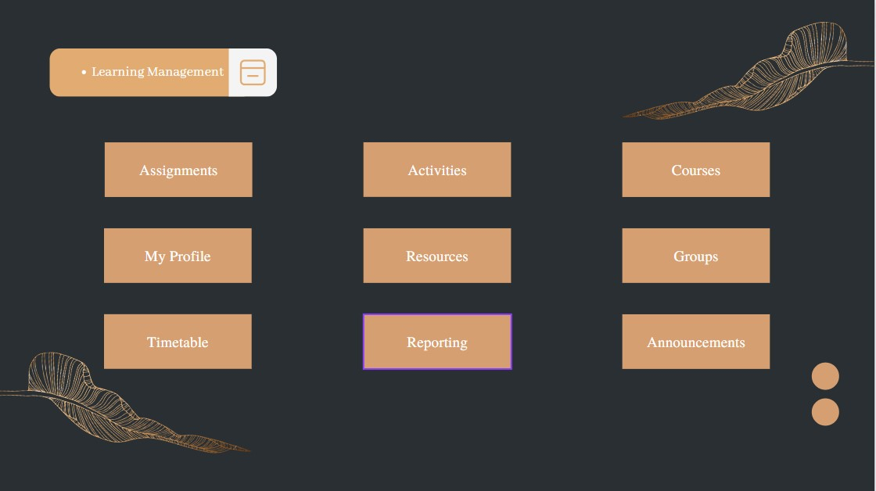

**Figure 7**: Students can manage everything related to their school life from their phone.

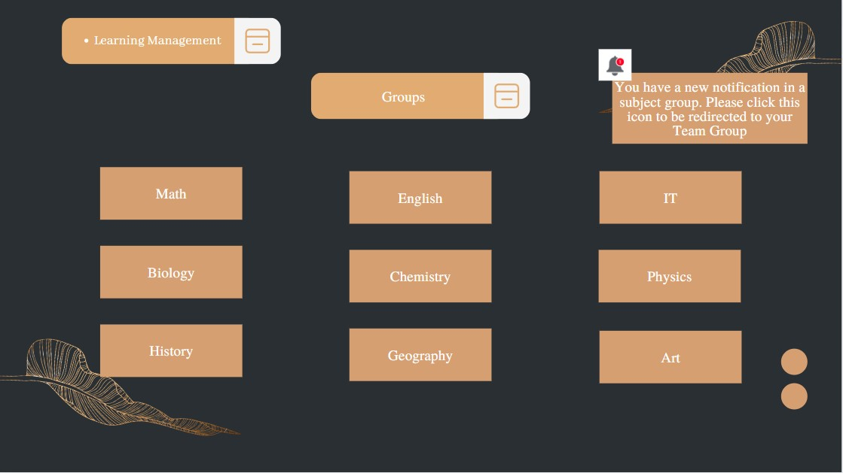

**Figure 8:** By clicking the notification takes the user to the most recent group subject discussion on their team group.

# **3.0 Existing systems Review (Attendance System):**

## **3.1 Taking attendance:**

Taking attendance is a way in which the students can take their marks for the classes attended and the activities that are scheduled by the school. In the current educational system, performance evaluation and quality control depend on students' consistent attendance in class. (Bhattacharya et al., 2018). A child's academic progress is significantly influenced by their attendance at school and unborn life chances plus it enables them to get a range of educational and social openings (Guest, 2022). Previously paper-grounded attendance When operating the classes, educational institutions use an operating system that can be quite time-consuming for both students and preceptors. (Md. Humaun Kabir, 2022) For this reason, they have developed electronic attendance systems that use, for example, a student's fingerprint or face recognition system. (Alghamdi, S.2019). A lot of educational institutes use automatic attendance machines for handling the attendance of numerous approaches using biometric technology, one of them is the appeal of the face. This device may be used to address the issue of fake attendance. The main operations of this machine are identifying faces and detecting them. Afterward, by cross-referencing the identified faces with the database of students' faces, the contrast of the face images may be established. (Wagh et al. 2015).

### **3.1.1 Issues:**

Due to an undetermined worldwide arrestment brought on by the COVID-19 epidemic, schools had to be closed for several months. In several nations, schools were frequently closed to pupils, and preceptors had influence over educational conditioning through digital bias or homeschooling funds. (Roe, A., & Dalland, C. P.2021). Since then and some students may face health problems and may visa issues if a student is an international, in this case, the students will attend classes fully online. So, their attendance will not be counted because the school uses a system of face recognition. And the disadvantage is time-consuming as all physical students must queue for identification at the face detector (Alghamdi, S.2019). To counter these problems, an automated attendance system needs to be implemented and be more efficient.

### **3.1.2 Proposed Solutions:**

People increasingly prefer smartphones as their primary communication form over traditional desktops or notebooks. This is due to the speed and convenience that smartphones offer. (Masalha and Hirzallah, 2014). So, we need a secure and controllable way to enable all students to get the attendance score and transfer attendance data so that we can be able to create a new attendance system. The proposal is a process that uses random QR codes to accomplish scanning results. Furthermore, to improve system security, we employ network configuration and QR codes. The local network used by the attendance system method allows for direct interaction between the client and the server (students and teachers). To utilize the attendance system, the guest should be logged onto a local network. The guest must launch the app after connecting to scan the QR code that the server app has provided. A packet comprising identification data is transmitted from the user's smartphone to the server app after the scanning procedure is complete. When a user sends a packet across the local network, the server will accept it and analyze it. The server chooses a unique QR code while you wait. 100 scenarios are used to assess the system's efficiency. And students must connect to the local network and launch the App in these instances to verify their existence. They can also sign in by providing their username and password to the server to identify them. And the questionnaire form can be used to get replies from applicants concerning the system. (Muhammad Imanullah 2022).

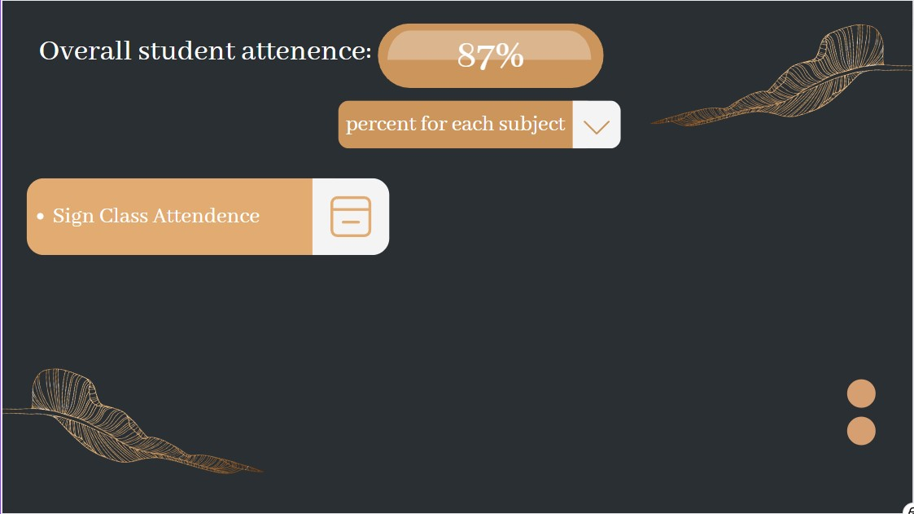

**Figure 9:** Page showing overall attendance.

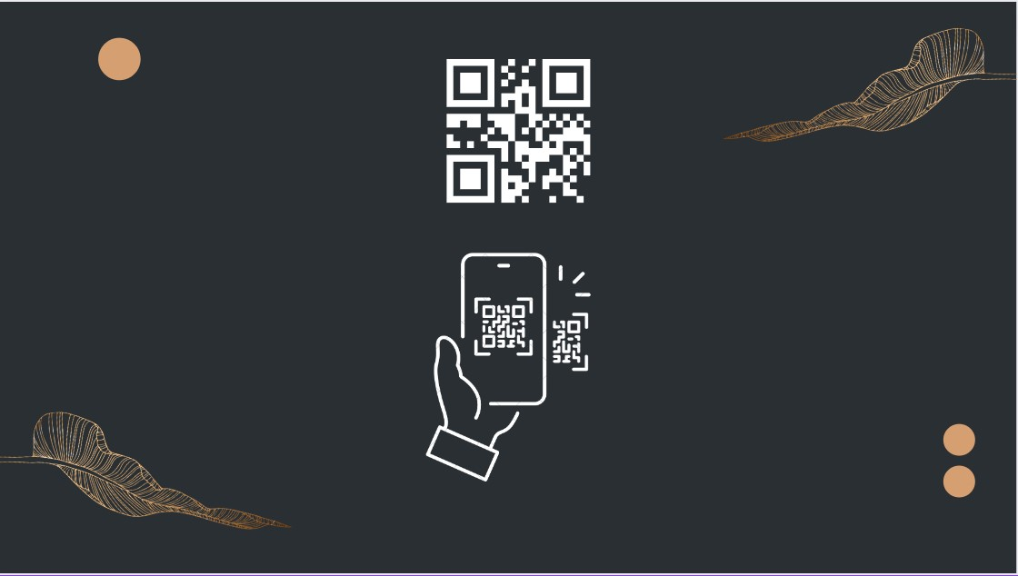

**Figure 10:** Students get their attendance by scanning the QR code.



**Figure 11:** Confirmation page showing the attendance was registered correctly.

## **3.2 Attendance tracking**:

Attendance tracking can simply be defined as a method to keep track or maintain the attendance of people in an organization, moreover attendance tracking in high school means making sure that the students are maintaining their attendance.

Attendance tracking software is a computer program used to track attendance. Examples of attendance tracking systems in high school include quick schools, timetable, class dojo and my attendance tracker (Gupta, 2022).

### **3.2.1 Issues:**

Poor attendance tracking in high school is simply the inability to keep track of the attendance of the students due to some problems in the software or some gaps that were not covered in the software. Poor attendance tracking can be caused by problems caused by both student and faculty. The following are the problems associated with attendance tracking that lead to poor attendance tracking for online class attendants:

In high school the biggest problem that hinders attendance tracking is the confirmation of attendance especially for those who are attending the class online, most of the time there is no sure way for the teacher to determine whether the students were paying attention to her lesson this is because the attendance software is not programmed well enough to determine whether the student was there for the whole lesson.

Another problem with lack of confirmation in attendance tracking is confirming missed attendance, it is well known that in most attendance tracking software incorporates a reason section when a student misses their attendance but these reasons have no way of being confirmed making them more of excuses rather than credible reason, for example when a student fakes an illness so they skip class they can simply report that they are ill without any credibility, which in fact is a common tendency in most high school students. Apart from confirmation problems from fake illnesses, high school students also use family matters to their advantage. These students make up false family emergencies as excuses to skip classes because the software has no means to determine whether there was an actual family emergency or not but once the reason typed in is family emergency it will be credited as an acceptable reason but there is no way to confirm the credibility of the reason

For the high schools that have physical classes but use attendance tracking software they might have similar problems, but their biggest problem is the number of students that are attending in class could hinder the attendance tracking due to the substantial number of students attending in one class. When there are too many kids in class it is easy to trick the software as easily as tricking the teacher because students can send OTP code to one another with ease.

### **3.2.2 Proposed Solutions:**

As big as the problems are there are always solutions for the problems, the following are the solutions implemented to solve them.

To solve the confirmation problem which helps credit all the absence from class the attendance system software should incorporate a form of document attachment that would help credit those who claim absent from class, examples of documents would include official hospital reports to credit illnesses and parent notes with signatures to credit family emergencies.

To solve the confirmation of students in online class being fully in class the attendance software should try to incorporate frequent in between class activities that would help maintain the focus of the students

To solve the problem of teachers trying to keep track of attendance in the attendance tracking system for the physical class attendees, the attendance tracking software system should try integrate in the software sitting plan system where the class is mapped out and the students select a specific seat in class and every sit allocated is visible to everyone in the system this way the teacher will be able to notice when there’s an empty spot when there’s supposed to be a person (aplus+ attendance)

For both the fully online students and the hybrid students who are attending physical classes the attendance tracking software should a special slot for parents which would help both the students and the faculty in keeping track of the student's attendance.

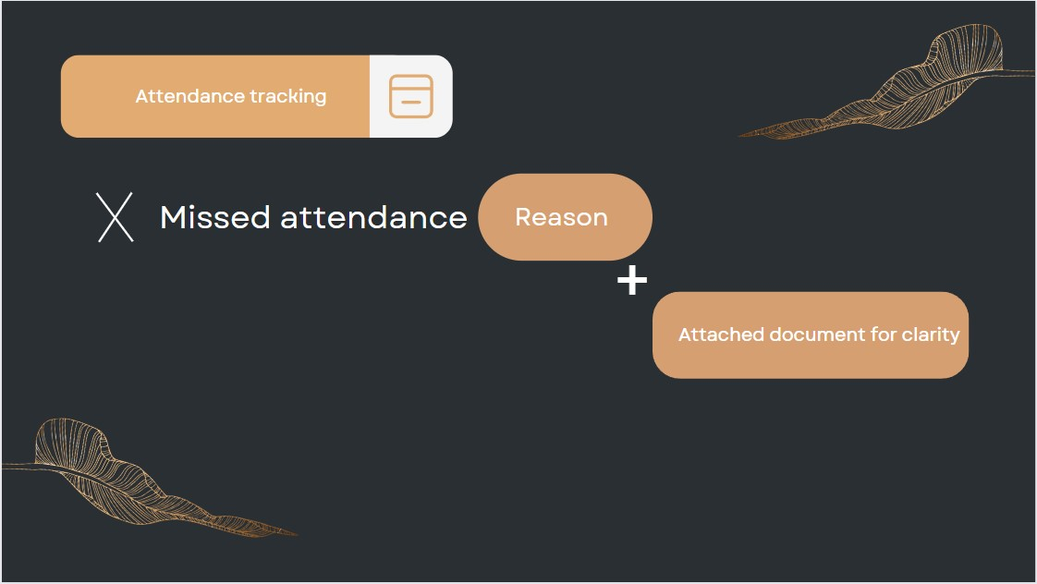

**Figure 12:** The system allows students to send a reason along with attached evidence if applicable which will then be reviewed by the teacher and who will then give the student the attendance missed.

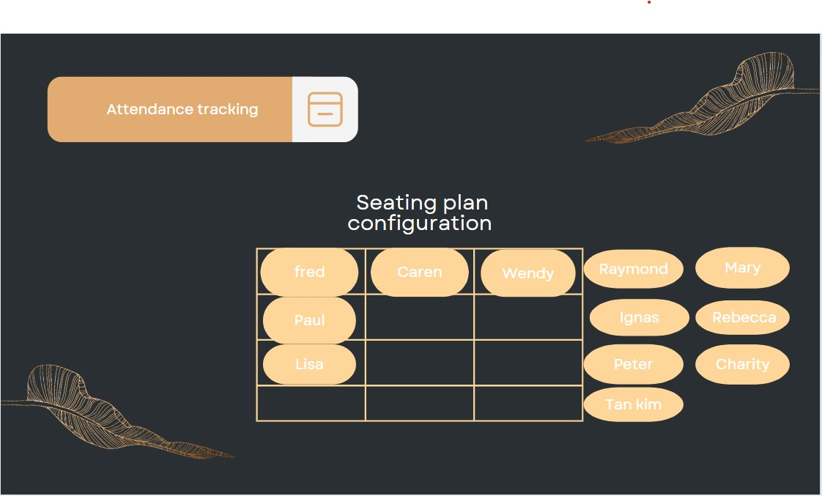

**Figure 13:** Mapped out class and sitting plan.

(732 words)

# **4.0 Existing systems Review (Identification System):**

## **4.1 Identity Management:**

Identity management is a feature used to ensure access to the technology and platform for the authorized people only to perform their tasks on it. When organizations implement an identity access system, their provocation is normally not primarily to manage a set of identities, but rather to give appropriate access rights to those entities through their identities. For internal use, identity management is evolving to control access to all digital assets, including devices, network equipment, servers, portals, content, applications, and/or products (Access Denied. (n.d.)).

### **4.1.1 Issues:**

Identity theft plays a massive role when it comes to disrupting identity management systems created by schools to manage the students’ personal information. Identity theft occurs when fraudsters gain access to identity information like personal details. Student identity theft is overly sensitive and dangerous targeting students and teenagers because fraudsters use minor information to commit financial fraud like applying for a student loan and many other crimes. Adding to that, people could be trying to gain access to the identity management part of the school system just to gain the students’ information and cause harm to either the school or the students.

### **4.1.2 Proposed Solutions:**

Fortunately, it is possible to be protected from identity theft, if each high school created its own educational software platform that would decrease flaws and enhance privacy in their system. The best solution is creating a platform that asks for all the student’s credentials, encourages students to create only strong passwords while asking them every 2 weeks to change it just to be sure that no one always knows the password. As soon as a student logs in, the system immediately sends a confirmation message via SMS text message or email to the student's associated email asking if it was the student who just tried to log in. If it was, the system permits the user to continue using the app as usual; however, if it wasn't the student, the system immediately blocks the user from entering and sends a notifying email to the actual owner of the account.

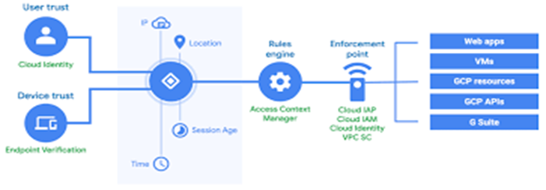

**Figure 14: System** checks the student’s location and IP address.

## **4.2 Identification cards:**

What is student id? It is a card that is given to the student that contains information such as name, unique number, and photo (Top Hat, 2020). To identify the students in high school, teachers ask for them to enter their ID number in the section allotted for it in the exam to ensure they are not someone else. student id can give access to enter some places like the library, campus, and classroom. Student id can be used in a lot of things to buy anything from the cafeteria, vending machines, and of course to top up money

The student id is a unique identification number assigned to every student enrolled in a university. This number is used to identify the student and to access diverse services offered by the institution (*Student Identification Number (SID) | Financial Aid*. (n.d.).

-The primary purpose of having a student id is that it helps you get hold of all the facilities and services provided by your university. You can use it online, on campus, and even offline.

The pros of using a student id includes helping you to get access to various facilities and services that are available at your school, and helps you connect with others who are also studying at the same institution (*Just a moment. . .* (anti cheating? n.d.).

Student id is a digital identity that allows students to access their school records, as well as other services.

The main benefits of having a student id are to access to your school's website, to be granted access to the internet anywhere on campus, and to gain access to services like the library.

### **4.2.1 Issues:**

The most common issue that schools face is when the system crashes due to an overload in the instructions, which happens due to inefficient data management capabilities of the system. The data given to the system when students try to perform tasks like topping up their student cards manually causes the system to overload and shutdown causing the entire school to stop whatever work is currently being done until the issue with the system is resolved.

### **4.2.2 Proposed Solutions:**

The solution is to create a software for Students to add their school ID cards on phones so they can top up easily, and the school can send them a notification whenever there is a system breakdown in school and when it will be solved so that students can manage the situation. The point of making the new software is to prevent schools and students from having many problems which include overloading students in one area and saving time. Students learn to be self-serving and to not depend on people around them.

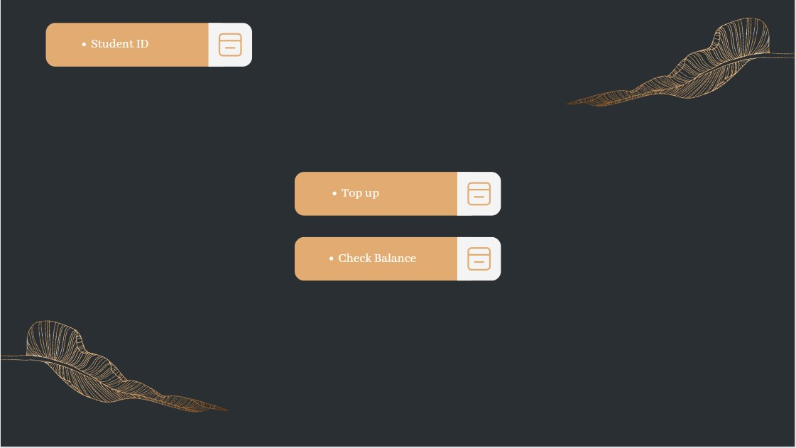

**Figure 15**: Students can check the balance on their cards from their phones.

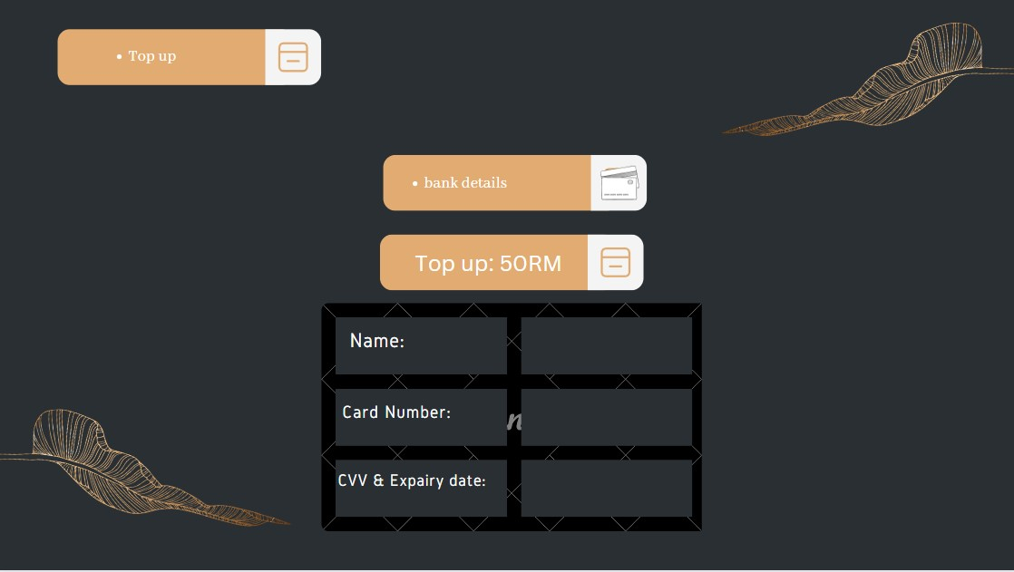

**Figure 16**: Students topping up their ID’s using their phones.

Students will be allowed to top up their ID cards with money without having to wait in long queues, which will avoid many problems related to overcrowding and missing classes.

# **5.0 Conclusion:**

The following shows the information system created.

Each student enters their TP Number and is then prompted to enter their password after the system recognizes them from the database of students and.

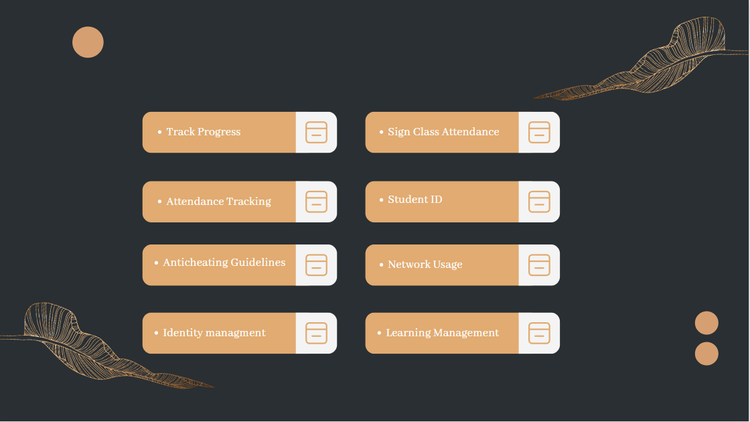

The information system combines all the solutions proposed by all the team members making it a fully complete system designed to be user friendly, efficient, and secure while maximizing the productivity features that will be used by the students and teachers. It can be accessed everywhere at any time using their phones laptops or tablets making it every convenient for all the users most of the data entered and stored will be computerized so the chances of an error happening are low.

When selected, each option takes you to further options related to the button clicked. When clicked on, Anti cheating guidelines show the students instructions on what to do during examination times like how to place the camera in order to show the student’s face and working space so that the teacher can identify what they’re doing. Network tracking shows the network and time spent on every app in order to see what the students use the devices offered by the school for. Learning management and progress tracking work hand in hand where progress tracking allows students to track their progress when it comes to assignments and exams to check how much they’ve improved from the previous test to the current time and learning management allows the students to manage their groups and work distribution for different assignments and allows people to communicate with others with them in the assignment group. The student ID option allows students to either check their information on their student cards or top their student cards up with money with the click of a button on their phones. Identity management option allows the students to check if there are any changes that need to be made to their information stored in the school systems and allows them to change their account password to make sure that no one other than them can have access to their information. Attendance taking and tracking also work hand in hand where attendance is taken using the QR code displayed by the teacher in class and attendance tracking allows the students and teachers to see who missed which class on each day separately.

(5504 Words)

# **6.0 References:**

* (PDF) A Students Attendance System Using QR Code. (2014). ResearchGate. [https://doi.org/10.14569\/IJACSA.2014.050310](https://doi.org/10.14569/IJACSA.2014.050310)
* (PDF) Biometric and Cloud-Based Attendance Monitoring System for Educational Institutes. (2022). ResearchGate; ResearchGate. <https://www.researchgate.net/publication/364380316_Biometric_and_Cloud-Based_Attendance_Monitoring_System_for_Educational_Institutes>
* AJ (2022). Can Online Courses Detect Cheating? [online] LMS Hero. Available at: <https://lmshero.com/can-online-courses-detect->
* Allen, D. (2020, November 21). *Pros & Cons of Student ID Cards - Benefits You Should Know*. InstantCard. <https://instantcard.net/pros-and-cons-of-student-id-cards/>
* Almoslamani, Y. (2018). Effectiveness of Student Engagement Using Learning Management System in the Blended Learning Environment at Saudi Electronic University. <https://digscholarship.unco.edu/cgi/viewcontent.cgi?article=1478&context=dissertations>
* Ansari, J. A. N., & Khan, N. A. (2020). Exploring the role of social media in collaborative learning, the new domain of learning. Smart Learning Environments, 7(1). <https://doi.org/10.1186/s40561-020-00118-7>
* Ashok Deepan. (2022, November 15). The Importance of High School in a Student’s life - GIIS Noida. Globalindianschool.org; GIIS Noida. <https://noida.globalindianschool.org/blog-details/the-importance-of-high-school-in-a-students-life>
* Assessing And Tracking Students Accurately And Continuously. (2021, April 9). EDBlog. <https://blog.edclass.com/assessing-and-tracking-students-accurately-and-continuously/>
* Balan, A., Montemayor, T., & Dalisay, J. (2021). The Influence of Online Learning towards the Attention Span and Motivation of College Students.
* Borup, J., Walters, S. and Call-Cummings, M. (2020). Student Perceptions of Their Interactions with Peers at a Cyber Charter High School. *Online Learning*, 24(2). doi:10.24059/olj.v24i2.2015.
* Barrington, Kate. “The Pros and Cons of Tracking in Schools.” Public School Review, Public School Review, 9 Dec. 2020, <https://www.publicschoolreview.com/blog/the-pros-and-cons-of-tracking-in-schools>
* Bhattacharya, S., Nainala, G. S., Das, P., & Routray, A. (2018). Smart Attendance Monitoring System (SAMS): A Face Recognition Based Attendance System for Classroom Environment. 2018 IEEE 18th International Conference on Advanced Learning Technologies (ICALT). <https://doi.org/10.1109/icalt.2018.00090>
* Cecil Hills High School. (2021). Nsw.gov.au. <https://cecilhills-h.schools.nsw.gov.au/students/moodle-and-links.html>
* Chang, S., & Kuo, A. C. (2021). Indulging interactivity: a learning management system as a facilitative boundary object. SN Social Sciences, 1(2). <https://doi.org/10.1007/s43545-021-00069-x>
* cheating/#:~:text=How%20To%20Detect%20Cheating%20In%20Online%20Exams%201 [Accessed 3 Dec. 2022].
* Du, Z., Fu, X., Zhao, C., Liu, Q., & Liu, T. (2012). Interactive and Collaborative E-Learning Platform with Integrated Social Software and Learning Management System. Lecture Notes in Electrical Engineering, pp. 11–18. <https://doi.org/10.1007/978-3-642-34531-9_2>
* Faghih, B., Reza, M., & Katebi, Prof. S. D. (2014). User Interface Design for E-Learning Software. ArXiv.org. <https://doi.org/10.7321/jscse.v3.n3.119>
* Green, C. (2021, September 22). Monitoring Student Needs and Progress in a Student-Centered Classroom. Michigan Virtual. <https://michiganvirtual.org/blog/monitoring-student-needs-and-progress>
* Guest, L. (2022, March 8). Improving School Attendance. Twinkl; Twinkl. <https://www.twinkl.co.uk/blog/improving-school-attendance>
* Karlson, S. (2020, December 8). Why Tracking Student Progress Is Critical to Solving the Achievement Gap: 6 Questions for District Leaders. Learning Sciences International. <https://www.learningsciences.com/blog/tracking-student-progress-district-leaders/>
* Lambda Solutions. (2022, March 9). *12 Keys for Avoiding Identity Theft When Learning Online*. Www.lambdasolutions.net. <https://www.lambdasolutions.net/blog/12-keys-for-avoiding-identity-theft-when-learning-online>
* Machado, M., & Tao, E. (2007). Blackboard vs. Moodle: Comparing user experience of learning management systems. 2007 37th Annual Frontiers in Education Conference - Global Engineering: Knowledge without Borders, Opportunities Without Passports. <https://doi.org/10.1109/fie.2007.4417910>
* McAfee. (2022, August 5). *5 Common Types of Identity Theft*. McAfee Blog. <https://www.mcafee.com/blogs/privacy-identity-protection/5-common-types-of-identity-theft/>
* Nicholls, G.M. and Lewis, N. (2017). *Using a Course Learning Management System to Promote Academic Honesty*. [online] ResearchGate. Available at: <https://www.researchgate.net/publication/323884173_Using_a_Course_Learning_Management_System_to_Promote_Academic_Honesty> [Accessed 15 Dec. 2022].
* Noorbehbahani, F., Mohammadi, A. and Aminazadeh, M. (2022). A systematic review of research on cheating in online exams from 2010 to 2021. *Education and Information Technologies*, [online] 27(6), pp.8413–8460. doi:10.1007/s10639-022-10927-7.
* Panyajamorn, T., Suanmali, S., Kohda, Y., Chongphaisal, P., & Supnithi, T. (2018). Effectiveness Of E-learning Design and Affecting Variables in Thai Public Schools. Malaysian Journal of Learning and Instruction, 15(1), 1–34. <https://files.eric.ed.gov/fulltext/EJ1185780.pdf>
* Pokhrel, S., & Chhetri, R. (2021). A Literature Review on Impact of COVID-19 Pandemic on Teaching and Learning. Higher Education for the Future, 8(1), 133–141. <https://doi.org/10.1177/2347631120983481>
* Randomized QR-code scanning for a low-cost secured attendance system : International Journal of Electrical and Computer Engineering (IJECE) : Free Download, Borrow, and Streaming : Internet Archive. (2022, August). Internet Archive. <https://archive.org/details/10.11591ijece.v12i4.pp3762-3769/mode/2up?view=theater>
* Renaissance. (2022b, October 3). What is progress monitoring? | EdWords. <https://www.renaissance.com/edword/progress-monitoring/>
* Rodríguez-Ardura, I., & Meseguer-Artola, A. (2016). E-learning continuance: The impact of interactivity and the mediating role of imagery, presence, and flow. Information & Management, 53(4), 504–516. <https://doi.org/10.1016/j.im.2015.11.005>
* Roe, A., & Dalland, C. P. (2021). The Impact of COVID-19 and Homeschooling on Students' Engagement With Physical Activity. Frontiers in Sports and Active Living. <https://doi.org/10.3389/fspor.2020.589227>
* Rosier, S., PhD. (2021, August 25). 14 Effective Ways to Meet the Individual Needs of Students. wikiHow. <https://www.wikihow.com/Meet-the-Individual-Needs-of-Students>
* Rubenking, N. J. (2022, November 3). *Prevent Identity Theft With These 11 Essential Steps*. PCMAG. <https://www.pcmag.com/how-to/prevent-identity-theft-online>
* SS, A. (2016). Cheating in ELearning. 7 things HR professionals need to know. [online] Olive Group. Available at: <https://olivegroup.io/cheating-in-elearning-7-things-hr-professionals-need-to-know/> [Accessed 3 Dec. 2022].
* This Is What School Was Like 100 Years Ago. (2022, November 11). Reader’s Digest. Retrieved November 30, 2022, from <https://www.rd.com/list/what-school-was-like-100-years-ago/>
* Thomas, A. (2018, March 9). What Does the High School Core Curriculum Include? AllEducationSchools.com. <https://www.alleducationschools.com/blog/what-the-high-school-curriculum-covers/>
* Top Hat. (2022). *Student Identification Definition and Meaning*. Top Hat. <https://tophat.com/glossary/s/student-identification/>
* Turnbull, D., Chugh, R., & Luck, J. (2020). Learning Management Systems, An Overview. Encyclopedia of Education and Information Technologies, 985–1058. <https://doi.org/10.1007/978-3-030-10576-1_248>
* Wagh, P., Thakare, R., Chaudhari, J., & Patil, S. (2015). Attendance system based on face recognition using eigen face and PCA algorithms. 2015 International Conference on Green Computing and Internet of Things (ICGCIoT). <https://doi.org/10.1109/icgciot.2015.7380478>
* What American education was like 100 years ago. (2020, September 6). Stacker. Retrieved November 30, 2022, from <https://stacker.com/education/what-american-education-was-100-years-ago>
* What were classrooms like 100 years ago? (n.d.). What Were Classrooms Like 100 Years Ago? - Ash Tutors. Retrieved November 30, 2022, from [https://www.ashtutors.co.uk/parenting/what- were-classrooms-were-like-100-years-ago.html](https://www.ashtutors.co.uk/parenting/what-%20were-classrooms-were-like-100-years-ago.html)
* [www.youtube.com](http://www.youtube.com). (n.d.). Cheating Is Easier Than Ever For Online College Students | TODAY. [online] Available at: <https://www.youtube.com/watch?v=Jfv2uU6xl64&ab_channel=TODAY> [Accessed 3 Dec. 2022].
* Yale. (2022). *Student Identification Number (SID) | Financial Aid*. Finaid.yale.edu. <https://finaid.yale.edu/award-letter/financial-aid-terminology/student-identification-number-sid>
* Top Hat. (2020, January 26). *Student Identification Definition and Meaning*. <https://tophat.com/glossary/s/student-identification/>
* *Student Identification Number (SID) | Financial Aid*. (n.d.). <https://finaid.yale.edu/award-letter/financial-aid-terminology/student-identification-number-sid>
* *Just a moment. . .* (n.d.). <https://instantcard.net/pros-and-cons-of-student-id-cards/>
* Benefits of Designing ID Card using School Management System Webpage·2020·Fedena. <https://fedena.com/blog/2018/10/benefits-designing-id-card-using-school-management-system.html>
* *aplus+ attendance.* (n.d.). Retrieved from <https://aplusattendance.com/en/he-student-attendance-tracking-software>
* Gupta, S. (2022, November 29). *best online attendance system for students during an online class*. Retrieved from techjoy: <https://www.techjockey.com/blog/best-online-attendance-system-for-students#:~:text=5%20Best%20Online%20Attendance%20System%20for%20Students%20Used,...%204%20ClassDojo%20...%205%20MyAttendance%20Tracker%20>
* Nicholls, G.M. and Lewis, N. (2017). *Using a Course Learning Management System to Promote Academic Honesty*. [online] ResearchGate. Available at: <https://www.researchgate.net/publication/323884173_Using_a_Course_Learning_Management_System_to_Promote_Academic_Honesty> [Accessed 15 Dec. 2022].
* Rubenking, N. J. (2022, October 3). *Prevent Identity Theft With These 11 Essential Steps*. PCMAG. <https://www.pcmag.com/how-to/prevent-identity-theft-online>
* Rosencrance, L., & Mathias, C. (2021, September 29). *identity management (ID management)*. Security. <https://www.techtarget.com/searchsecurity/definition/identity-management-ID-management>
* Solutions, L. (2022, March 14). *12 Keys for Avoiding Identity Theft When Learning Online*. Lambda Solutions. <https://www.lambdasolutions.net/blog/12-keys-for-avoiding-identity-theft-when-learning-online>
* *Access Denied*. (n.d.). <https://www.vmware.com/topics/glossary/content/identity-management.html>

# **7.0 Appendices:**

## **7.1 Work breakdown Structure:**

|  |  |  |  |
| --- | --- | --- | --- |
| No. | Names (TP Number) | Task / Responsibility | Signature |
| 1 | Ibraheem Mohammed Imadeldin Awad  (L)    (TP070765) | 2.1, 2.1.1, 2.1.2, the figures below this part.  5.0 and 7.0  Assigning the work.  Managing and making final changes.  20% Contribution to the work |  |
| 2 | Abdulrahman Gamil Mohammed Ahmed    (TP07012) | 3.1, 3.1.1, 3.1.2, the figures below these parts.  Introduction.  WBS  17% Contribution to the work |  |
| 3 | Fouad Mohamed    (TP069613) | 4.1, 4.1.1, 4.1.2, the figure below these parts.  10% Contribution to the work |  |
| 4 | Saif Waleed Abdelrahman Sayed Abdelsalam    (TP068702) | 2.2, 2.2.1, 2.2.2, the figure below these parts  7% Contribution to the work |  |
| 5 | Adham Sobhy Abdalla Elshazly    (TP068700) | 2.3, 2.3.1, 2.3.2, the figure below these parts.  10% Contribution to the work |  |
| 6 | Abdul Shafey Khan  (TP071166) | 2.4, 2.4.1, 2.4.2, Compiling references and formulating a final list.  17% Contribution to the work |  |
| 7 | Abdul Rahman Awadh Masoud    (TP069361) | 4.2, 4.2.1, 4.2.2, the figures below these parts.  9 % Contribution to the work |  |
| 8 | Hans William kihigwa    (TP071413) | 3.2, 3.2.1, 3.2.2, the figures below these parts.  10% Contribution to the work |  |